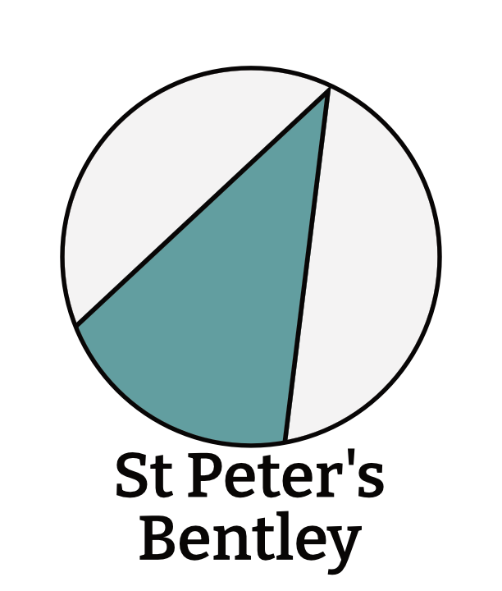
Parish Administrator
Person Specification
May 2023

Criteria | Essential | Desirable
Qualifications | - GCSE English and Maths at grade C or above, or equivalent | - IT Qualification
Experience | - Office work experience  - Social Media experience  - Communication and publicity materials experience  - Diary experience  - Customer Service experience | - Experience of DBS administration  - Project Management experience  - Working in a faith context
Knowledge | - Excellent at Social Media  - Understanding of the activities of the Church of England at parish level | - Understanding of Parochial Fees
Technical and Applied Skills | - Knowledge of Microsoft Word, Excel, and Sharepoint | - Knowledge of Wordpress  - Experience of the ChurchSuite database  - Experience of Affinity (Designer/Publisher/Photo) or similar.  - Basic IT troubleshooting skills
Personal Attributes | - Willing to go the extra mile to give good service  - Skills in confident, but friendly communications  - Great organisational skills  - Self motivated, good at prioritising  - Team player  - Sympathetic to the Ethos of the Church.

There is no occupational requirement to be a Christian to undertake this role. But the successful candidate will need to be sympathetic to our ethos and undermining this could be considered a disciplinary matter.

